Gazette Notification of 7th Central Pay Commission-Download now
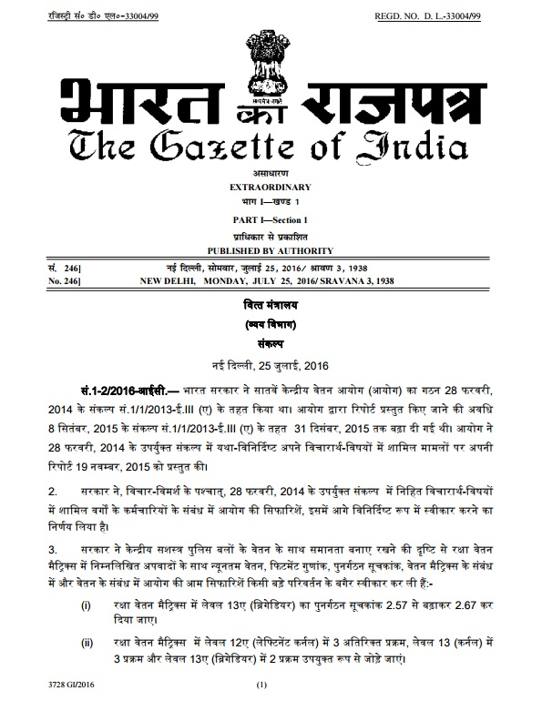

Gazette Notification – Download now
MINISTRY OF FINANCE
(Department of Expenditure)
RESOLUTION
New Delhi, the 25th July, 2016
No. 1-2/2016-IC.— The Seventh Central Pay Commission (Commission) was set up by the Government of India vide Resolution No. 1/1/2013-E.III (A), dated the 28th February, 2014. The period for submission of report by the Commission was extended upto 31st December, 2015 vide Resolution No. 1/1/2013-E.III(A), dated the 8th September, 2015. The Commission, on 19th November, 2015, submitted its Report on the matters covered in its Terms of Reference as specified in the aforesaid Resolution dated the 28th February, 2014.
2. The Government, after consideration, has decided to accept the recommendations of the Commission in respect of the categories of employees covered in its Terms of Reference contained in the aforesaid Resolution dated the 28th February, 2014 in the manner as specified hereinafter.
3. The Government has accepted the Commission’s recommendations on Minimum Pay, Fitment Factor, Index of Rationalisation, Pay Matrices and general recommendations on pay without any material alteration with the following exceptions in Defence Pay Matrix in order to maintain parity in pay with Central Armed Police Forces, namely :-
(i) the Index of Rationalisation of Level 13A (Brigadier) in Defence Pay Matrix may be revised upward from 2.57 to 2.67;
(ii) additional three stages in Levels 12A (Lieutenant Colonel), three stages in Level 13 (Colonel) and two stages in Level 13A (Brigadier) may be added appropriately in the Defence Pay Matrix.
4.
(1) The Pay Matrix, in replacement of the Pay Bands and Grade Pays as in force immediately prior to the notification of this Resolution, shall be as specified in Annexure I in respect of civilian employees.
(2) With regard to fixation of pay of the employee in the new Pay Matrix as on 1st day of January, 2016, the existing pay (Pay in Pay Band plus Grade Pay) in the pre-revised structure as on 31st day of December, 2015 shall be multiplied by a factor of 2.57. The figure so arrived at is to be located in the Level corresponding to employee’s Pay Band and Grade Pay or Pay Scale in the new Pay Matrix. If a Cell identical with the figure so arrived at is available in the appropriate Level, that Cell shall be the revised pay; otherwise the next higher cell in that Level shall be the revised pay of the employee.
(3) After fixation of pay in the appropriate Level as specified in sub-paragraph (2) above, the subsequent increments in the Level shall be at the immediate next Cell in the Level.
5. There shall be two dates for grant of increment namely, 1st January and 1st July of every year, instead of existing date of 1st July; provided that an employee shall be entitled to only one annual increment on either one of these two dates depending on the date of appointment, promotion or grant of financial up-gradation.
6. The Commission’s recommendations and Government’s decision thereon with regard to revised pay structure for civilian employees of the Central Government and personnel of All India Services as specified at Annexure I and the consequent pay fixation therein as specified at Annexure II shall be effective from the 1st day of January, 2016. The arrears on this account shall be paid during the financial year 2016-2017.
7. The recommendations on Allowances (except Dearness Allowance) will be referred to a Committee comprising Finance Secretary and Secretary (Expenditure) as Chairman and Secretaries of Home Affairs, Defence, Health and Family Welfare, Personnel and Training, Posts and Chairman, Railway Board as Members. The Committee will submit its report within a period of four months.
Till a final decision on Allowances is taken based on the recommendations of this Committee, all Allowances will continue to be paid at existing rates in existing pay structure, as if the pay had not been revised with effect from 1st day of January, 2016.
8. The recommendations of the Commission relating to interest bearing Advances as well as interest free Advances have been accepted with the exception that interest free Advances for Medical Treatment, Travelling Allowance for family of deceased, Travelling Allowance on tour or transfer and Leave Travel Concession shall be retained.
9. The recommendations of the Commission for increase in rates of monthly contribution towards Central Government Employees Group Insurance Scheme (CGEGIS) for various categories of employees has not been accepted. The existing rates of monthly contribution shall continue. Department of Expenditure and Department of Financial Services will work out a customised group insurance scheme for Central Government employees.
10. The Government has accepted the recommendations of the Commission on upgrading of posts except for those specified at Annexure III. The recommendations on upgradation specified at Annexure III will be separately examined by Department of Personnel and Training for taking a comprehensive view in the matter.
11. The Government has not accepted the recommendations of the Commission on downgrading of posts and normal replacement will be provided in such cases.
12. While revising the pay of Doctors in respect of whom Non Practicing Allowance is admissible and Railway employees in respect of whom Running Allowance is admissible, it will be ensured that the actual raise in pay at the time of initial fixation is about 14.29 percent as recommended by the Commission.
13. The pay of officers posted on deputation under Central Staffing Scheme will be protected and the difference in the pay will be given to them in the form of Personal Pay to be made effective from the date of notification.
14. Recommendations not relating to pay, pension and allowances and other administrative issues specific to Departments/Cadres/Posts will be examined by the Ministries/Departments concerned as per the Allocation of Business Rules or Transaction of Business Rules. Until a decision is taken by the Government on administrative issues pertaining to
(i) Non Functional Upgradation (NFU) presently admissible to the Indian Police Service/Indian Forest Service and Organised Group ‘A’ Services,
(ii) two years’ edge to Indian Administrative Service officers vis-a-vis other All India Services/Organised Group ‘A’ Services in empanelment under Central Staffing Scheme,
(iii) grant of two additional increments at Senior Time Scale, Junior Administrative Grade and Selection Grade to Indian Police Service and Indian Forest Service at par with Indian Administrative Service and Indian Foreign Service
(iv) a uniform retirement age for all ranks in Central Armed Police Forces, where the Commission could not arrive at a consensus, status quo shall be maintained.
15. A Committee of Secretaries comprising Secretaries of Departments of Personnel and Training, Financial Services and Pension and Pensioners’ Welfare will be set up to suggest measures for streamlining the implementation of the National Pension System (NPS).
16. Anomalies Committees will be set up by Department of Personnel and Training to examine individual, post-specific and cadre-specific anomalies arising out of implementation of the recommendations of the Commission.
17. Regarding pay and related issues concerning All India Services, appropriate action will be taken by Department of Personnel and Training to give effect to the decisions on these matters as may be applicable to them.
18. The Government of India wishes to place on record their appreciation of the work done by the Commission.
ORDER
Ordered that this Resolution be published in the Gazette of India, Extraordinary.
Ordered that a copy of this Resolution be communicated to the Ministries/Departments of the Government of India, State Governments, Administrations of Union Territories and all other concerned.
R.K. CHATURVEDI, Jt. Secy
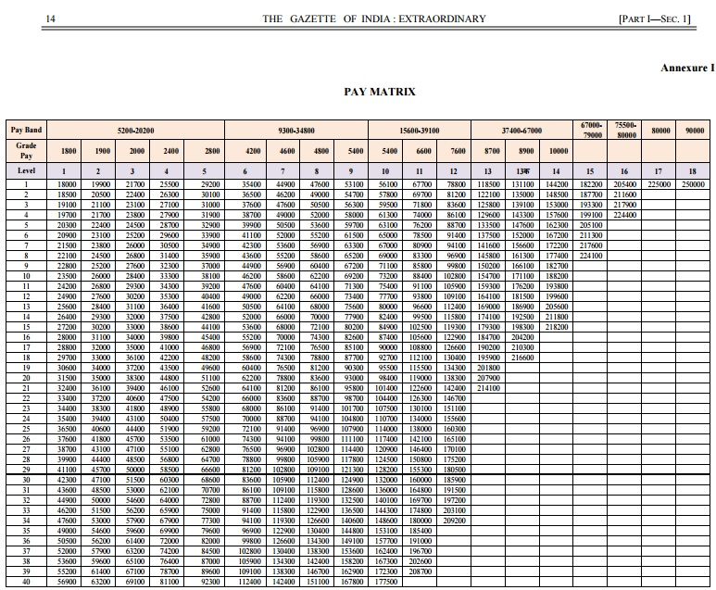
ANNEXURE II
Statement showing the recommendations of the Seventh Central Pay Commission on Pay relating to Civilian employees in Group ‘A’, ‘B’ and ‘C’ and personnel of All India Services and Government’s decisions thereon.
I. Pay Fixation in revised Pay Structure:
Sl.No | Recommendation of the Seventh Central Pay Commission | Decision of the Government
1 | Minimum pay in government with effect from 01.01.2016 at Rs. 18000 per month (Para 4.2.13 of the Report) | Accepted
2 | Pay Matrix comprising two dimensions having horizontal range in which each level corresponds to a “functional role in the hierarchy” with number assigned 1, 2, 3 and so on till 18 and “vertical range” denoting “pay progression”. These indicate the steps of annual financial progression (Para 5.1.21 of the Report) | Accepted
3 | On recruitment, an employee joins at a particular level and progresses within the level as per the vertical range. The movement is usually on an annual basis, based on annual increments till the time of their next promotion. (Para 5.1.22 of the Report) | Accepted
4 | The fitment factor of 2.57 to be applied uniformly for all employees. (Para 5.1.27 of the  Report) | Accepted
5 | Pay of employees to be fixed in the revised Pay Structure in the manner laid down in Paras 5.1.28 and 5.1.29 of the Report. | Accepted
6 | In case of upgrading of posts recommended by the Commission, the pay may be fixed in revised Pay Structure in manner laid down in Para 5.1.30 of the Report. | Accepted. The recommendationregarding downgrading not accepted and, therefore, no occasion for fixation on downgrading of posts.
7 | Pay of direct recruits will start at the minimum pay corresponding to the Level to which  recruitment is made, which will be the first cell of each Level in the Matrix (Para 5.1.32 of the Report) | Accepted
8 | On promotion, pay of employees to be fixed in the manner laid down in Para 5.1.33 of the Report. | Accepted
II. Annual Increments:
Sl.No | Recommendation of the Seventh Central Pay Commission | Decision of the Government
1 | The manner of drawal of annual increment to be as laid down in Para 5.1.53 of the Report. | Accepted
III.Modified Assured Carred Progression Scheme:
Sl.No | Recommendation of the seventh central Pay Commission | Decision of the Government
1 | MACP will continue to be administered at 10, 20 and 30 years as before. In the new Pay Matrix, the employee will move to immediate next Level in hierarchy. Fixation of pay will follow the same principle as that for a regular promotion in the Pay Matrix. MACPS will continue to be applicable to all employees up to Higher Administrative Grade (HAG) level except members of Organised Group ‘A’ Services. (Para 5.1.44 of the Report) | Accepted
2 | Benchmark for performance appraisal for promotion and financial ungrdation under MACPS to be enhanced from “Good” to “Very Good”. (Para 5.1.45 of the Report) | Accepted
3 | Withholding of annual increments in the case of those employees who are not able to meet the benchmark either for MACP or a regular promotion within the first 20 years of their service. (Para 5.1.46 of the Report) | Accepted
IV. Consolidated Pay Package in Regulatory Bodies:
Sl.No | Recommendation of the seventh Central Pay Commission | Decision of the Government
1 | Consolidated pay package of Rs. 4,50,000 (Rupees Four Lakh and Fifty Thousand only) for Chairpersons of Telecom Regulatory Authority of India, Central Electricity Regulatory Commission, Insurance Regulatory and Development Authority, Securities and Exchange Board of India, Competition Commission of India, Pension Fund Regulatory and Development Authority, Petroleum and Natural Gas Regulatory Board, Warehousing Development and Regulatory Authority, and Airports Economic Regulatory Authority of India (Para No. 13.15 (i) of the Report) | Accepted
2 | Consolidated pay package of Rs. 4,00,000 (Rupees Four Lakh only) for Members of Telecom Regulatory Authority of India, Central Electricity Regulatory Commission, Insurance Regulatory and Development Authority, Securities and Exchange Board of India, Competition Commission of India, Pension Fund Regulatory and Development Authority, Petroleum and Natural Gas Regulatory Board, Warehousing Development and Regulatory Authority, and Airports Economic Regulatory Authority of India (Para No. 13.15 (i) of the Report) | Accepted
3 | Consolidated pay package in above cases to be raised by 25 percent as and when Dearness Allowance goes up by 50 percent. All other benefits, including Travelling Allowance/Daily Allowance on tour etc., to be provided by the Regulatory Bodies as per their rules and regulations. (Para No. 13.15 (ii) of the Report) | Accepted
4 | Normal replacement pay for existing Members of the remaining regulatory bodies set up under Acts of Parliament. (Para No. 13.15 (iii) of the Report) | Accepted
V. Dearness Allowance:
Sl.No | Recommendation of the seventh Central Pay Commission | Decision of the Government
1 | Existing formula and methodology for calculating Dearness Allowance to continue  (Para 8.17.37 of the Report) | Accepted. The reference base for calculation of Dearness Allowance after coming into force of the revised Pay structure shall undergo change  accordingly and will be linked to the average index as on 01.01.2016.
Annexure III
List of cases of upgradation of posts recommended by seventh Central Pay Commission to be referred to Department of Personnel and Training
A (I). Upgradation other than Apex Level:
Sl.No | Name of Posts  (Para No. of Report of Seventh Central Pay Commission) | Present Grade Pay | Grade Pay recommended by seventh Central Pay Commission
1 | Junior Radiographer of Andaman and  Nicobar Islands Administration (7.7.50) | 2000 | 2800
2 | Preservation Assistant, Botanical Survey of India, Ministry of Environment, Forest and Climate Change (11.16.19) | 2000 | 2400
3 | Senior Technical Assistant (Survey), Ministry of Mines (11.29.15) | 4200 | 4600
4 | Senior Technical Assistant (Drawing), Ministry of Mines (11.29.15) | 4200 | 4600
5 | Technical Officer, Office of Textile Commissioner, Ministry of Textile (11.49.9) | 4200 | 4600
6 | Assistant Director Grade-II (Technical), Ministry of Textile (11.49.9) | 4600 | 4800
7 | Assistant Accounts Officer, Finance Division of Defence, Ministry of Defence  (11.12.140) | 4800 | 5400 )PB-2) on completion of 4 years service
8 | Senior Section Officer (Accounts), Ministry of Railways (11.40.83) | 4800
9 | Senior Travelling Inspector (Accounts),  Ministry of Railways (11.40.83) | 4800
10 | Senior Inspector (Store Accounts), Ministry of Railways (11.40.83) | 4800
11 | Chemical and Metallurgical Assistant (CMA), Ministry of Railways (11.40.124) | 4200 | 4600
12 | Chemical and Metallurgical Superintendent (CMS), Ministry of Railways (11.40.124) | 4600 | 4800
13 | Assistant Chemist and Metallurgist, Ministry of Railways (11.40.124) | 4800 | 5400 (PB-2)
A(II). Up-gradation to Apex Scale:
Sl.No | Name Of Post  (Para No.of Report of Seventh Central Pay Commission)
1 | Director General (Indian Coast Guard) (11.12.27)
2 | Director General, Central Statistics Office, Ministry of Statistics and Programme Implementation (11.47.9)
3 | Vice President of Income Tax Tribunal, Department of Legal Affairs (11.27.27)
4 | Head, National Defence College (NDC), New Delhi (14.21)
5 | Head, National Defence Academy (NDA), Khadakwasla, Pune (14.21)
6 | Head, Defence Services Staff College (DSSC), Wellington (14.21)
B. Cases recommended by Seventh Central Pay Commission in which no action is required:
Sl.No. | Name of Post  (Para No. of Report of Seventh Central Pay Commission) | Present Grade Pay | Grade Pay recommended by Seventh Central Pay Commission | Remarks
1 | Agriculture Assistant, Government of National Capital Territory of Delhi  (11.23.170) | 2400 | 2800 | Posts do not exist
2 | Gardner overseer, Government of National Capital Territory of Delhi  (11.23.170) | 2400 | 2800
3 | Group Level Worker, Government of National Capital Territory of Delhi (11.23.170) | 2400 | 2800
4 | ExtensionOfficer (Agriculture) Government of National Capital Territory of Delhi (11.23.170) | 2400 | 2800
5 | Farm Manager Junior, Government of National Capital Territory of Delhi  (11.23.170) | 2400 | 2800
6 | Assistant Store Keeper, Indian Bureau of Mines  (11.29.24) | 1900 | 2400 | This post already exists in Grade pay 2400
Gazette Notification of 7th Central Pay Commission-Download now

Two dates for grant of increment namely, 1st January and 1st July of every year

